|  |  |
| --- | --- |
| EDWARD W. FRANKE | 6601 Salida Way North Highlands, CA 95660 |
| 916-622-1602 edfranke@me.com |

**Objective:** A Data Analyst position.

KEY SKILLS

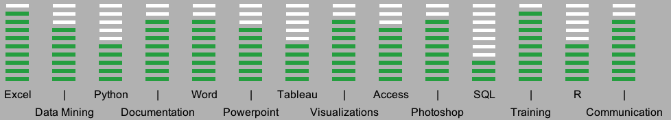

|  |  |
| --- | --- |
| **SKILLS** | **SOFTWARE** |
| Data extraction, Data cleaning, Data merging, Data presentation | Microsoft Excel, advanced/expert user |
| Root cause analysis, failure analysis, testing analysis and data analysis | Microsoft Word, Access, Powerpoint, Visio |
| Process procedures, flow charts, diagrams and reports documentation | UNIX (HP-UX) vi shell scripting |
| Create presentations for staff, management and customers. | Adobe Photoshop CS5 |
| Continuous Improvement, Total Quality Methodologies, | Company custom databases |
| 5s Lean Manufacturing | MS SQL, R, Python, Tableau |
| 10-key calculator |  |

|  |  |  |
| --- | --- | --- |
| **EDUCATION** |  |  |
| **University of Wisconsin – Superior Superior, WI** |  | Data Science Fundamentals |
| **Master of Science – Data Science** |  | Data Science Programming |
| Expected Graduation: June 2020 |  | Communicating Data |
|  |  |  |
| **Udemy Course Certificates** |  |  |
| SQL & Database Design A-Z: Learn PostgreSQL |  | Completed Jul. 2017 |
| Complete Python Bootcamp: Go from zero to hero |  | Completed Jul. 2017 |
| R Programming A-Z: R For Data Science |  | Completed Aug. 2017 |
|  |  |  |
| **William Jessup University Rocklin, CA** |  | Research Methods and Statistical Concepts |
| **Bachelor of Science – Business Administration** |  | Project Management |
| Jun. 2009 – May 2012 |  | Economics for Managers |
|  |  |  |
| **DeVry Institute of Technology Long Beach, CA** |  | Technical Math |
| **Associate of Science – Electronics** |  | Applied Physics |
| Jun. 1997 – Feb. 1999 |  | Computer Applications (Microsoft Office) |
|  |  |  |
| **Cypress College Cypress, CA** |  | Computer Literacy (Microsoft business software) |
| **Associate of Science – Business and Photography** |  | Accounting courses |
| Aug. 1991 – Dec. 1997 |  | Spreadsheet software |

|  |  |  |  |
| --- | --- | --- | --- |
| EDWARD W. FRANKE | | |  |
|  |
| **WORK EXPERIENCE** |  |  | | |
| **TSI Semiconductors. Roseville, CA** |  | **(Temporary Assignment with Volt July 2014-April 2015.** | | |
| Jul. 2014 – Feb. 2017 |  | **Converted to Regular Employee, April 2015.)** | | |
| *Wafer Fabrication Operator II* |  | * Analyzed data and graphs to verify machines operating within | | |
|  |  | specifications and to maintain product quality. | | |
|  |  | * Provided detailed quality documentation, inspections and | | |
|  |  | updates to the stakeholders and management. | | |
| **Fun Factory Honolulu, HI** |  | * Analyzed profit/loss statements, game performance and | | |
| Jul. 2013 – Jan. 2014 |  | metrics and inventory data to make business decisions. | | |
| *Store Manager* |  | * Created formulas in Excel to streamline process, increase | | |
|  |  | accuracy and improve efficiency in periodic and ad-hoc reports | | |
|  |  | * Drive amazing customer experiences through advocating for | | |
|  |  | them and the best match of services to their needs, adding | | |
|  |  | value, genuinely helping them and building loyalty. | | |
| **Cokeva (formerly Comtek) Roseville, CA** |  | * Analyzed databases for failure trends and anomalies to | | |
| Mar. 1999 – Oct. 2012 |  | determine potential common issues (ie date code, chip | | |
| *Quality and Documentation Administrator* |  | manufacturer, etc) | | |
| *and Technician II* |  | * Gathered, compiled, standardized data using MS Excel’s | | |
|  |  | formulas (ie len, left, right, vlookup, find, trim) to extract | | |
|  |  | useable data for reports, presentations (using MS Powerpoint) | | |
|  |  | and external customer databases. | | |
|  |  | * Created and enhanced standard, consistent, automatic and | | |
|  |  | sustainable data capturing and reporting. | | |
|  |  | * Analyzed customer data to machine test results to provide | | |
|  |  | reports and update customer databases. | | |
|  |  | * Conducted root cause and failure analysis investigations with | | |
|  |  | reports and recommendations for defective material. | | |
|  |  | * Analyzed test data to remove unnecessary testing which | | |
|  |  | increased the design capacity by 4800%. | | |
|  |  | * Wrote process documentation, procedures, flow charts and | | |
|  |  | diagrams (using MS Visio) to define expectations, required | | |
|  |  | steps and required results to support business goals and per | | |
|  |  | customer’s expectations and requests. | | |
|  |  | * Led engineering projects and processes with new product | | |
|  |  | development, UNIX shell scripting, test development, | | |
|  |  | debugging, training and documentation. | | |